1.

Front Page:

It needs to say:

Zara Pereira, Grade 12 student at The American School of Bombay

Music Connect

Reach

Teachers:

22 in Akanksha
20 in Aseema
15 at the ASB Teaching Academy
10 at Vipla

Adult instructors: 15 globally

Students: 1050 students and adults globally

Endorsements:

2. Can you add this icon/logo to the Music Connect page?

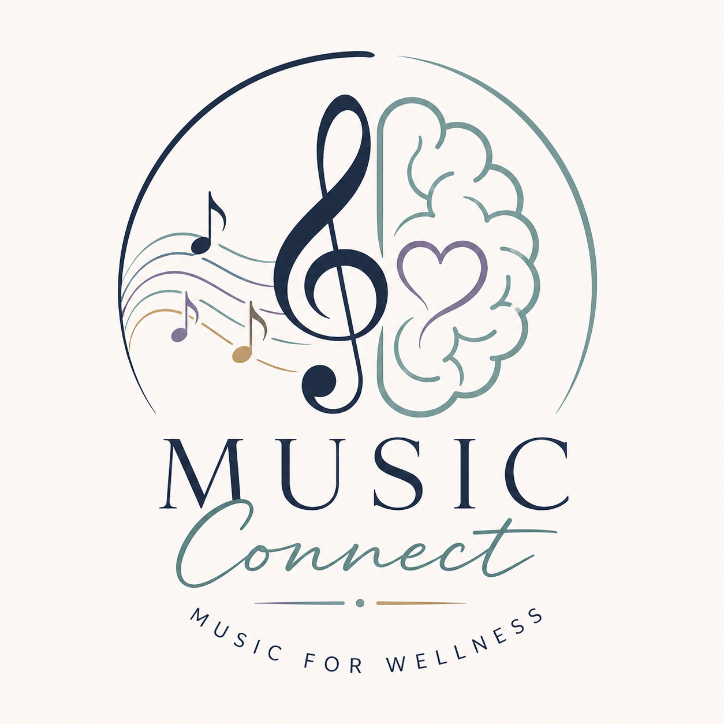

Does everything have to be in the centre?

The left and right of the page are quite bare.

3. The first example should be:

Internship with Music Therapist Sara D’Souza, August 2024-March 2025

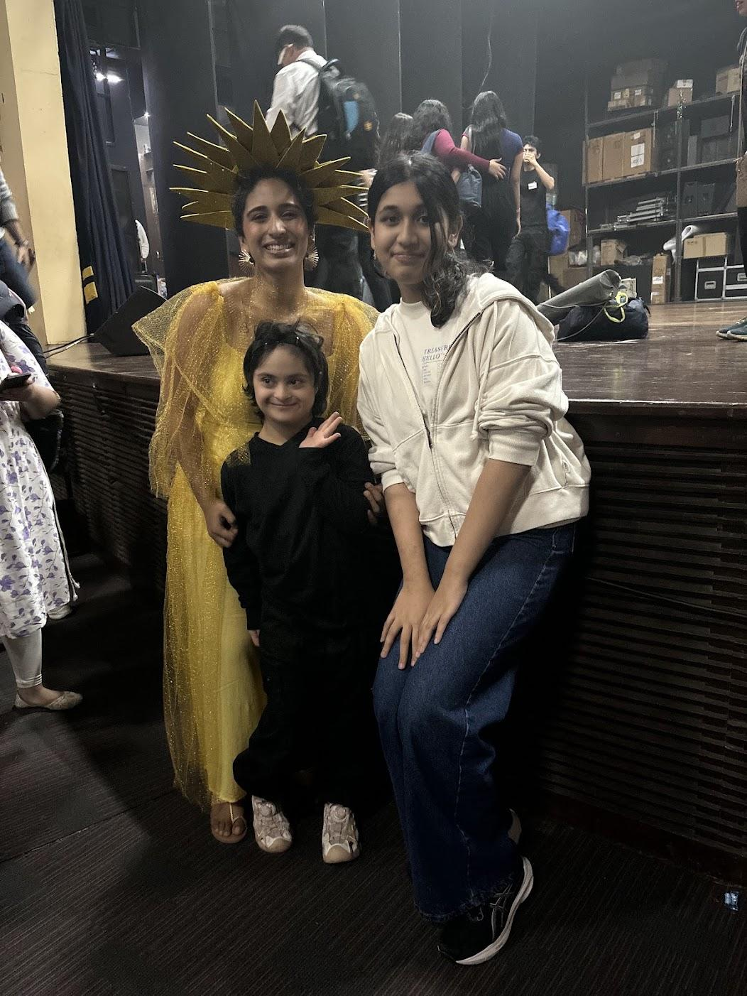

Ms D’Souza was kind enough to open up her private music therapy sessions to me. This internship was the catalyst for my interest in the intersection of music and psychology. I was given opportunities to observe, learn and even lead sessions. It was here that I formed a very special bond with a student, who was largely non-communicative, but who one day decided to call me “Mama” alongside her mother and Ms D’Souza.

SCHOOLS & SESSIONS

Aseema School, NGO, Mumbai
January 2026 to April 2026

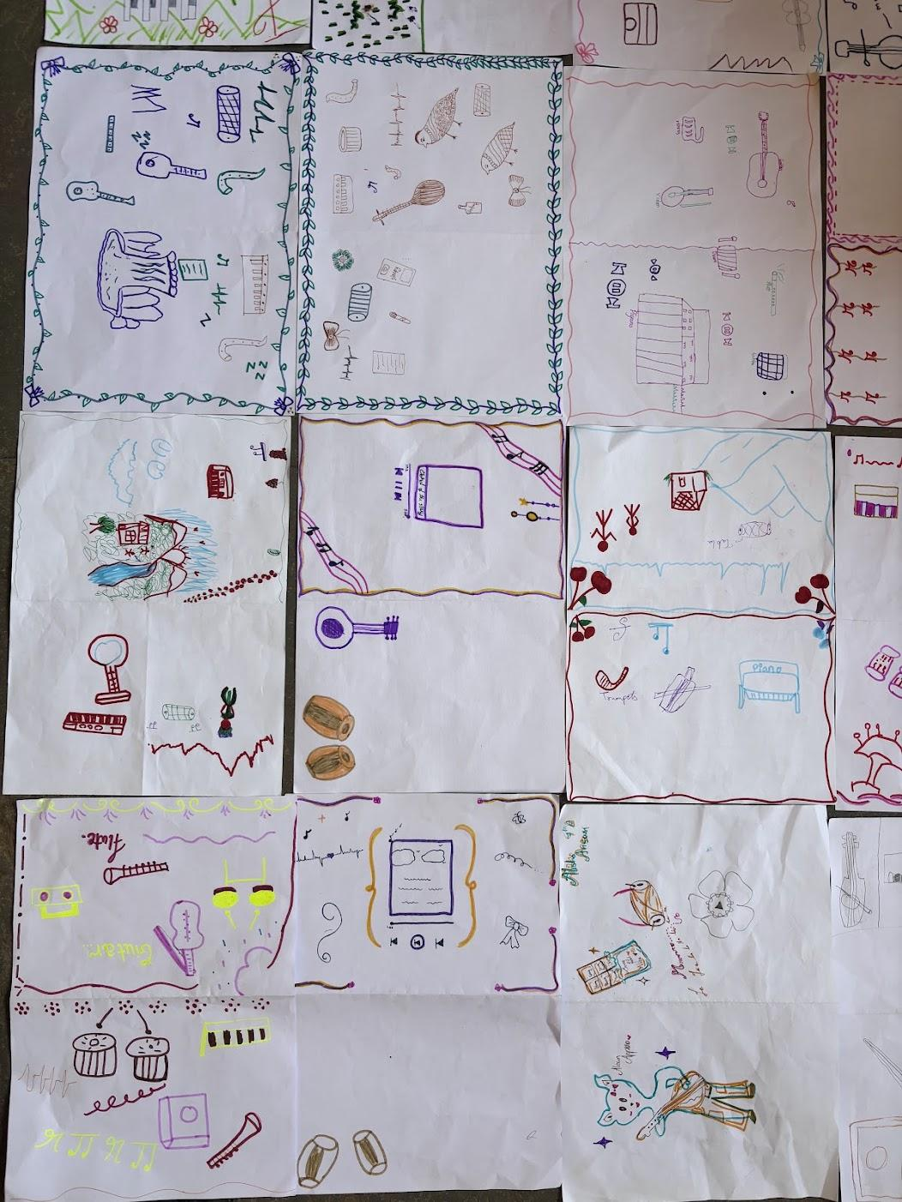

Please insert:

Vipla Foundation, April 2026

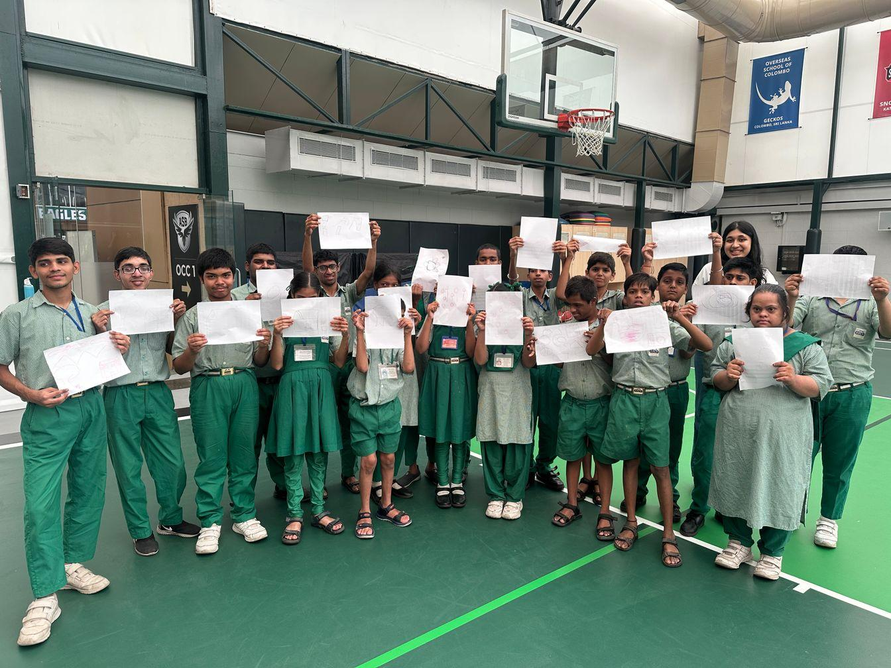

I was lucky enough to interact with the students and teachers of Vipla Foundation in BKC. Here my curriculum was adapted to meet the needs of non-verbal students. Music was the bridge that brought the group together.

Please add these images to Heavers

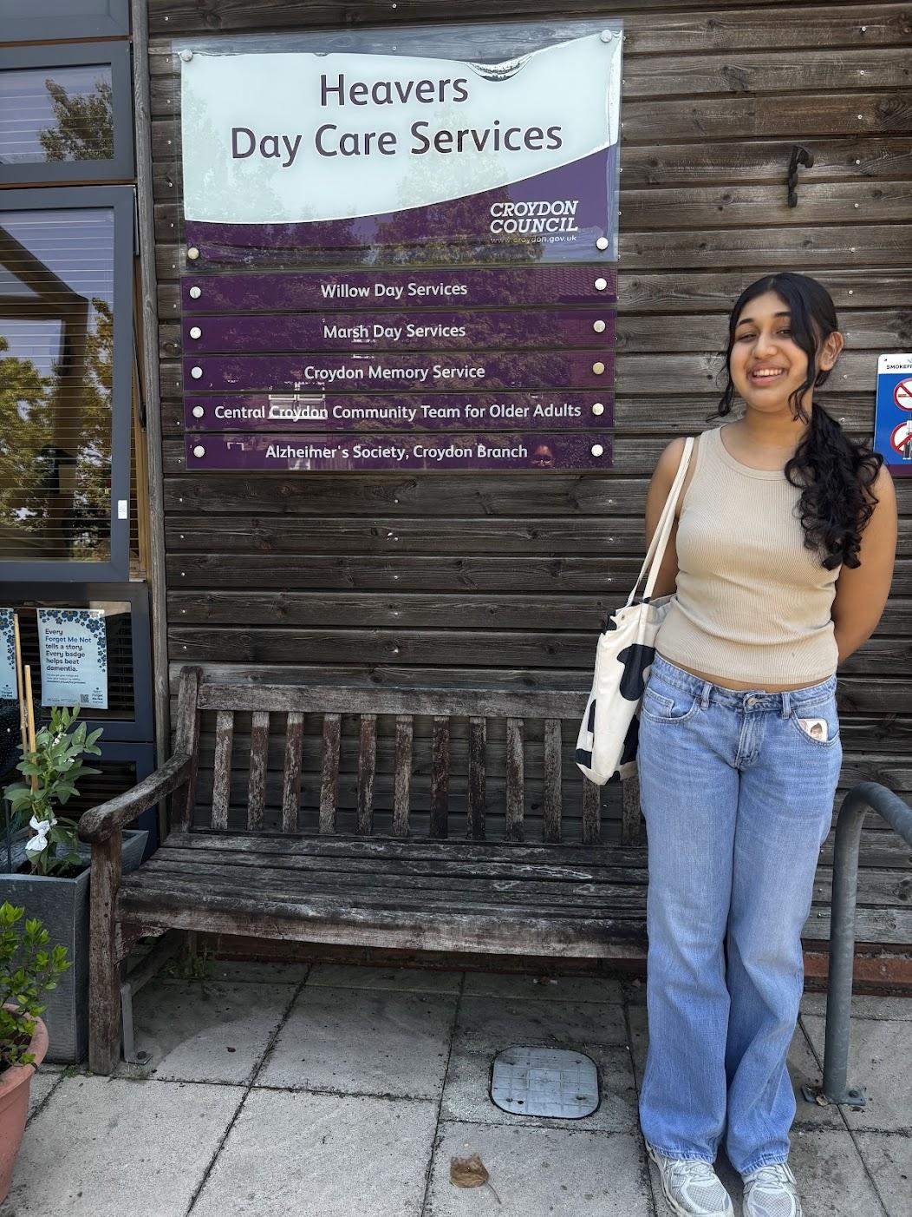

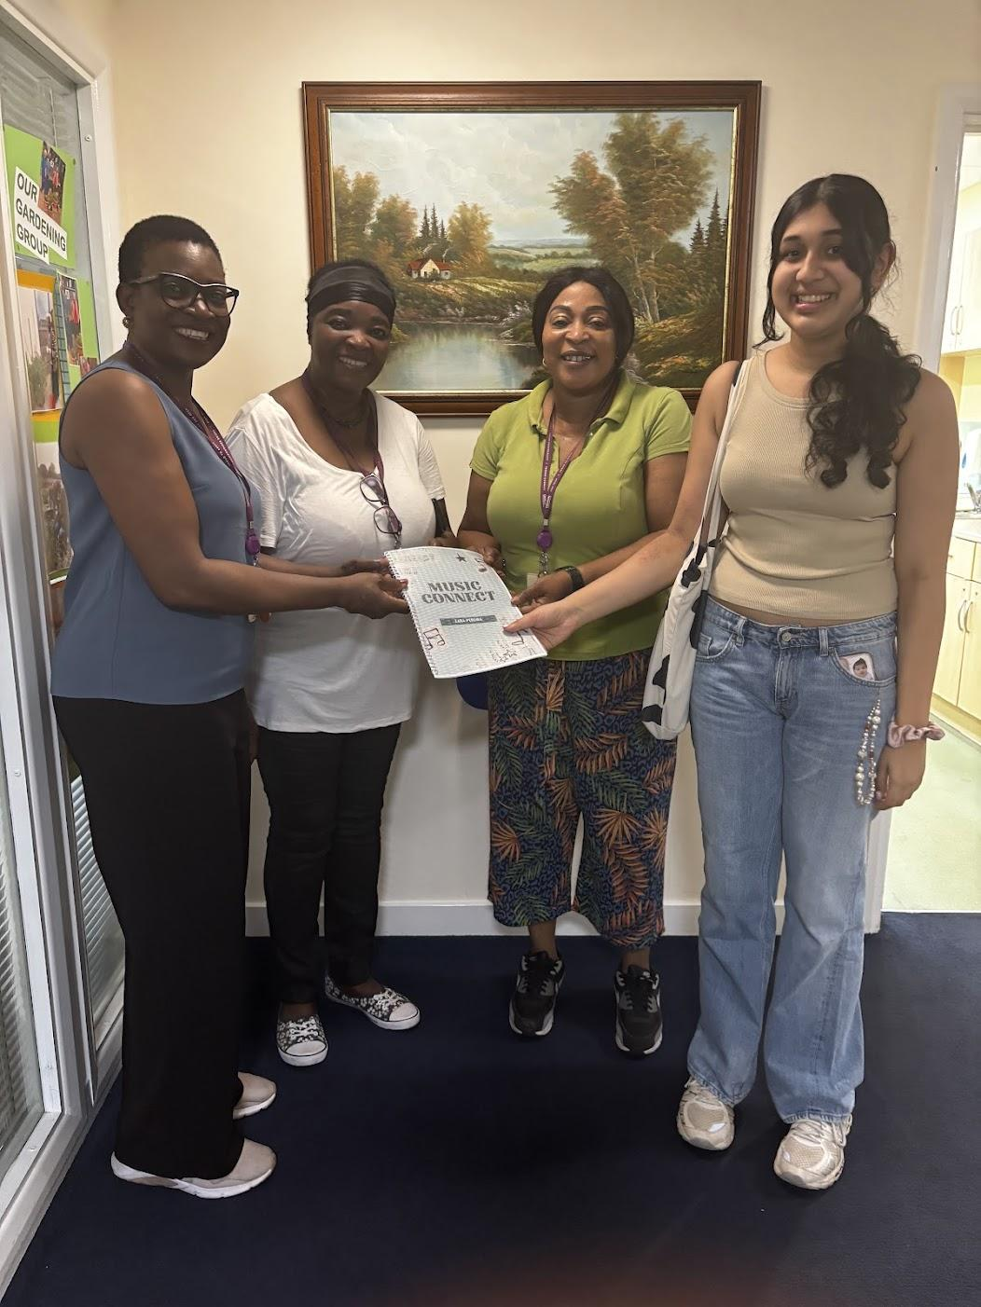

June to July 2026

My time at Heavers Day Care Services was meaningful as it is a Dementia Day Care centre which my Grandmother visits. It was a deeply personal and uplifting experience to bring my curriculum to the carers at the centre and for grandmother to enjoy watching me conduct the sessions for her companions. The carers are now implementing my curriculum.

Please add these to Sage Eldercare

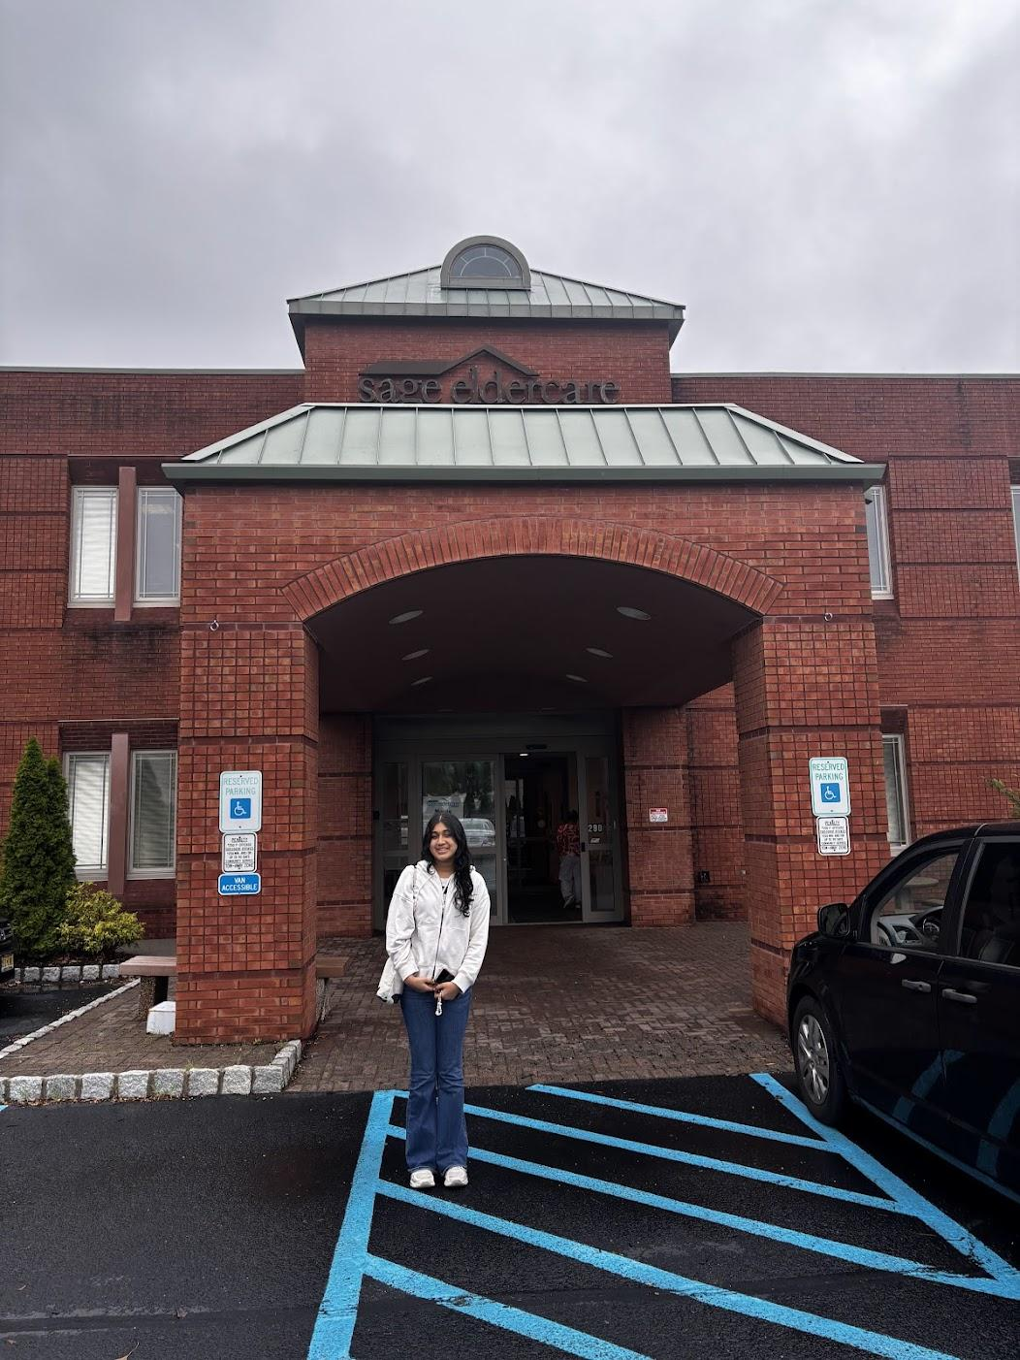

Please embed this videos:

https://photos.app.goo.gl/TLuSXERqVShHtp2BA

And this

https://photos.app.goo.gl/PrwR6tdG7iV8xDRW7

I interned at Sage Eldercare in New Jersey in July 2026. It was here that I was fortunate to introduce my curriculum, with some adaptations for the population. I also worked alongside a trained music therapist who taught me in collaborative song writing sessions with the residents.

